SKILL WEEK-4
SESSION-7

Task 1: Process Synchronization and Child Process Monitoring Using waitpid()
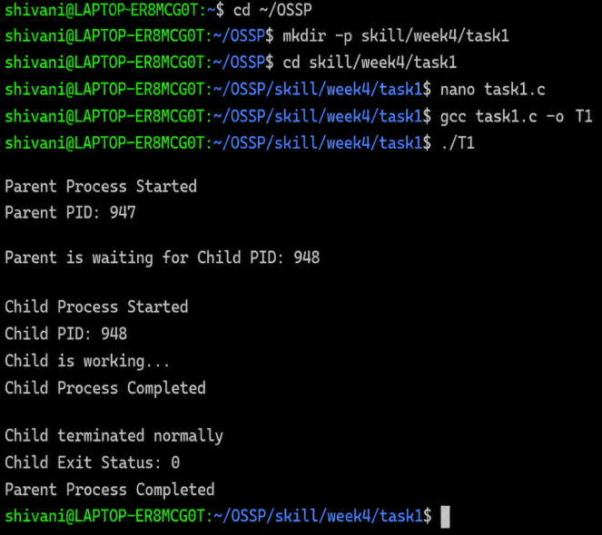
Observation: The program successfully creates a child process using fork() and uses waitpid() to make the parent process wait for the child process to complete. The child process executes its task and terminates normally with exit status 0. After receiving the child’s termination status, the parent process resumes and completes successfully. This demonstrates process synchronization and child process monitoring using waitpid().

Executables, Verify Permission, Handle Missing Commands, Test Command Resolution
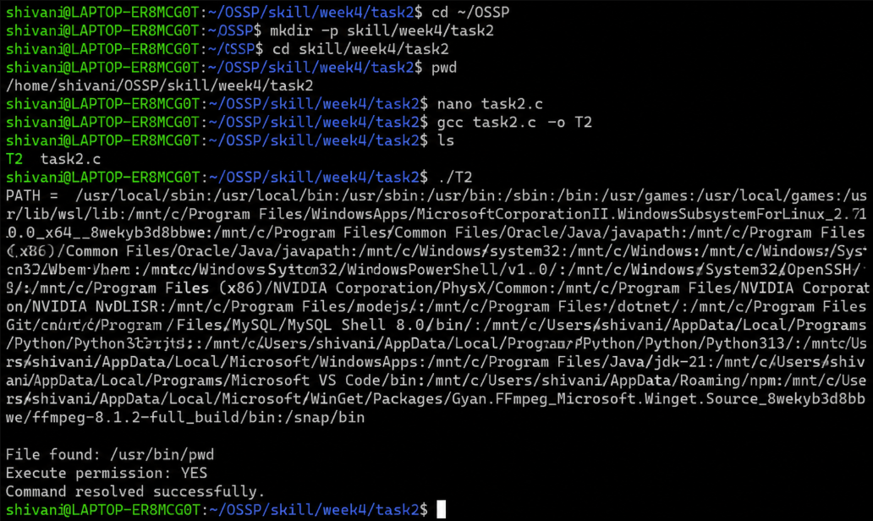

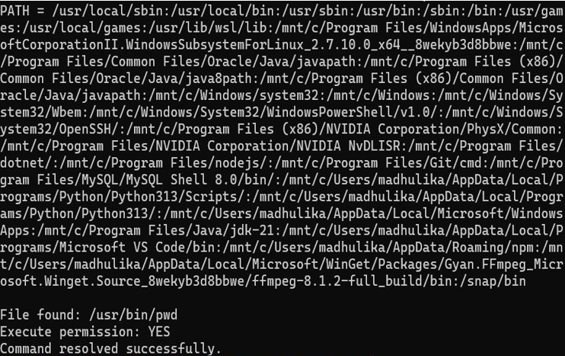

variable and searches through its directories to locate the specified command. For the valid command pwd, it finds /usr/bin/pwd and verifies that execute permission is available. For the invalid command Madhu, it correctly reports that the command is not found in PATH. Thus, the program successfully demonstrates PATH parsing, executable searching, permission verification, and handling of missing commands.
SESSION-8

Task 1: To Detect Variable References, Expand Values, Handle Undefined Variables, Update Tokens, Support Nested Variables, Test Expansion Logic. 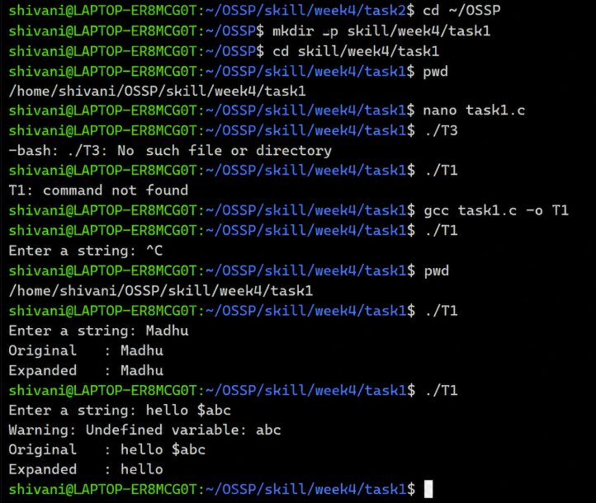
Observation: The program successfully detects variable references in the input string and expands the variable values using environment variables. For a normal string such as Madhu, the input remains unchanged. When an undefined variable such as $abc is entered, the program displays a warning and removes the undefined variable from the expanded output. Thus, the program successfully demonstrates variable detection, value expansion, and handling of undefined variables.

Built-ins, Handle Invalid Commands, Maintain State, Test Dispatch Logic.
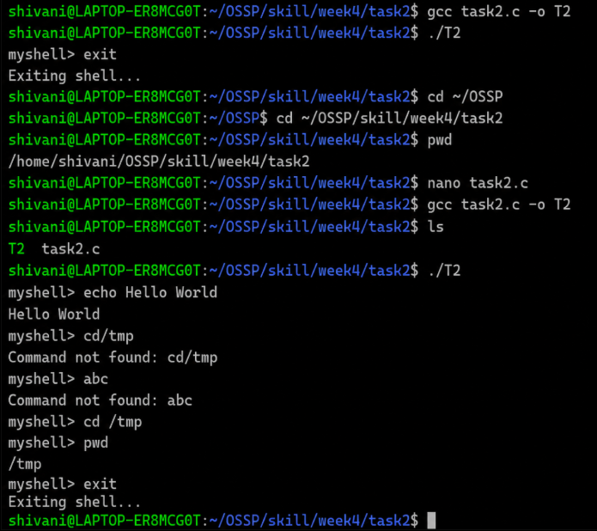
Observation: The program successfully identifies and executes built-in commands such as pwd, echo, cd, and exit using command dispatch logic. The cd command changes the current working directory and the change is maintained when pwd is executed again. Invalid commands are detected and reported as “Command not found.” Thus, the program successfully demonstrates built-in command identification, in-process execution, state maintenance, invalid-command handling, and dispatch logic testing.

